# PE10 – Introduction to OOP

1. Which of the following are real levels of accessibility in OOP?

friend

public

secure

private

protected

loose

wildcard

public, protected, private

1. "We must call the destructor of an object manually, or it will waste memory." True or False?

False.

1. Do you need to create an object in order to call a static method of its class?

No.

1. Using the yuml extension in Visual Studio Code, generate a UML diagram similar to the ones shown in this chapter for the following classes and interface:
2. An abstract class called HotDrink that has the methods Drink(), AddMilk(), and AddSugar (), and the properties Milk, and Sugar.
3. An interface called ICup that has the methods Refill() and Wash(), and the properties Color

and Volume.

1. A class called CupOfCoffee that derives from HotDrink, supports the ICup interface, and has the additional property BeanType.
2. A class called CupOfTea that derives from HotDrink, supports the ICup interface, and has the additional property LeafType.
3. Write some code for a function that would accept either of the two cup objects in the above example as a parameter. The function should call the AddMilk(), Drink(), and Wash() methods for any cup object it is passed.

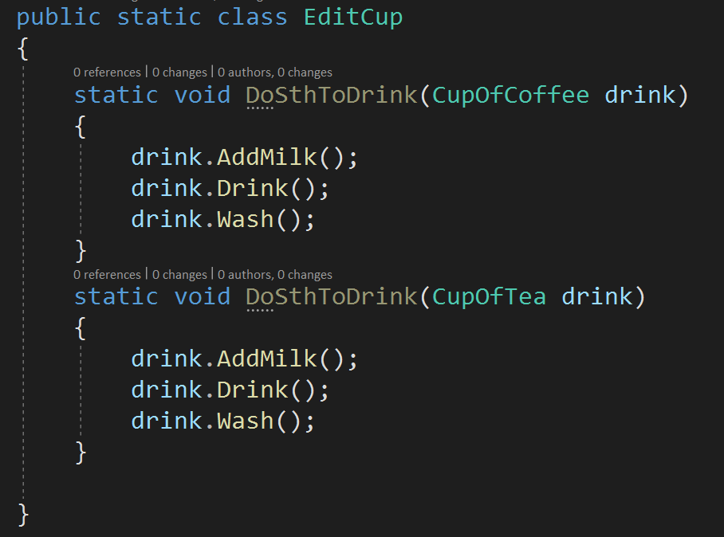

If it is called outside, public should also be added to DoSthToDrink

1. *Define the following terms.*

class: blueprint which specifies what can do

object: a block of memory allocated and configured by the definition of its class (an instance)

constructor: called when the object is constructed

field: variable that is declared in the class

method: code block that combines a series of statement

dot notation/dot syntax: tell instance to use a method/property in its class

encapsulation: make a black box that hides unnecessary data&inf from user

inheritance: allow to define parent and child class to inherit properties of a class

polymorphism: different objects share the same interface and implement by themselves

1. *True or False?*

T F You can create an object without a corresponding class.

T F A field is a variable belonging to a class.

T F A constructor is a special type of function that can only initialize a class’s fields.

Constructors cannot contain any other code to do anything else.

T F Class declarations do not need the class keyword.

T F Classes are data types, just like integer and Boolean.

T F There are other flavors of C# such as Ccheddar, Cswiss and Cmozzarella

1. What does it mean to have an overloaded method?

Redefine a method to implement polymorphism

1. Briefly explain how polymorphism can help store related objects in a collection.

They share some common properties, but they have some unique features, so we do not need to store them one by one. Instead, we create parent/child class to build relationship.

1. What does it mean to override a method?

Provide new implementation of method from inherited class

## Submission

Upload this completed document and the .SVG file for #4 to the corresponding MyCourses dropbox.